**C64 PSU Global Rev. 0**

**Module Description**

# Introduction

The C64 PSU Global is a replacement power supply for the Commodore C64, which is suitable to power the Commodore computer from 115V and 230V.

There are two options for transformers for the 9VAC, one is capable of being switch between 115V and 230V.

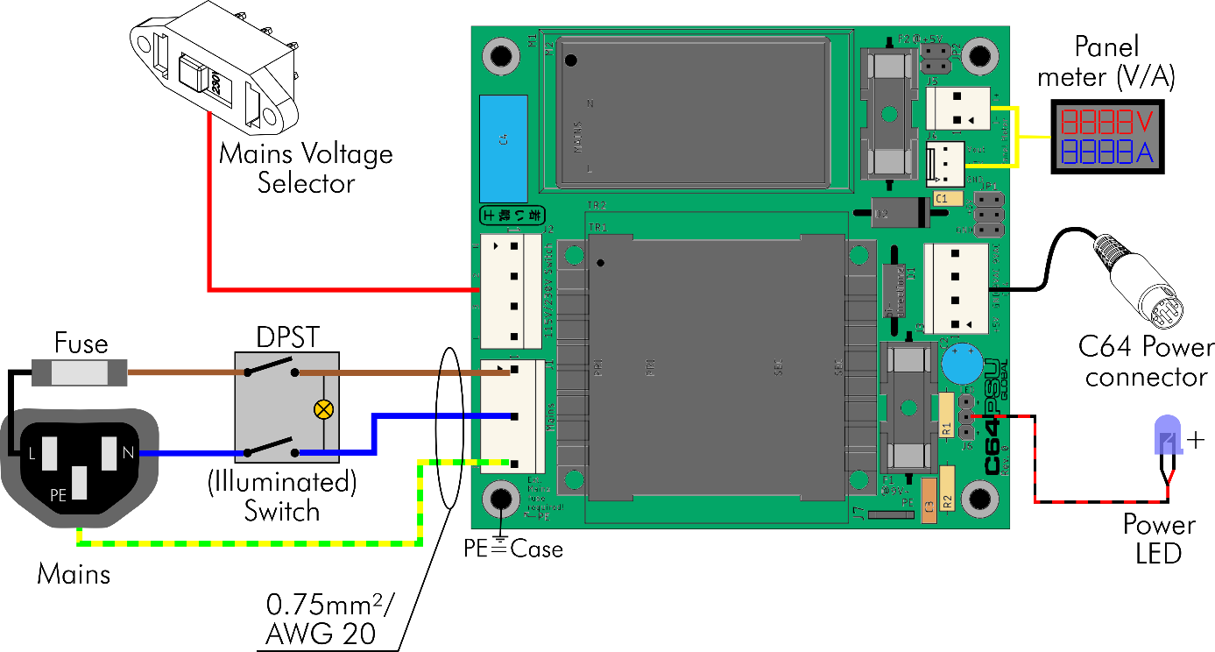

Figure 1: Block diagram

The 5VDC are generated by an AC/DC converter. There are two options that can be placed on the PCB, both have a wide range input (85VAC-264VAC) and are suitable for both main voltages without switching. The technical data of the power supply vary, depending on the chosen options:

|  |  |  |  |
| --- | --- | --- | --- |
| **Option** | **Type** | **Mains** | **Output** |
| Transformer TR1 | Hahn BV UI 304 0153 | 115VAC/230VAC | 9VAC/1.1A |
| Transformer TR2 | BREVE TUFVASSONS TEZ10/D230/9V | 230VAC | 9VAC/1.1A |
| AC/DC M1 | RECOM RAC10-05SK/277 | 85VAC-305VAC | 5VDC/2A |
| AC/DC M2 | Mean Well MPM-10-5 | 80VAC-264VAC | 5VDC/2A |

The mains voltage selector switch is only required for the option Transformer TR1. A fuse for the mains is external and mandatory. It is recommended to use a combination of mains with an integrated fuse and maybe a switch. The switch should switch off both, the hot and the neutral mains. In Figure 1, an illuminated mains switch is shown. Its lamp is located at the switched side.

A power LED can be connected. At least one signal should allow the use to notice, whether the PSU is switched on or off, the Power LED or the illuminated mains switch.

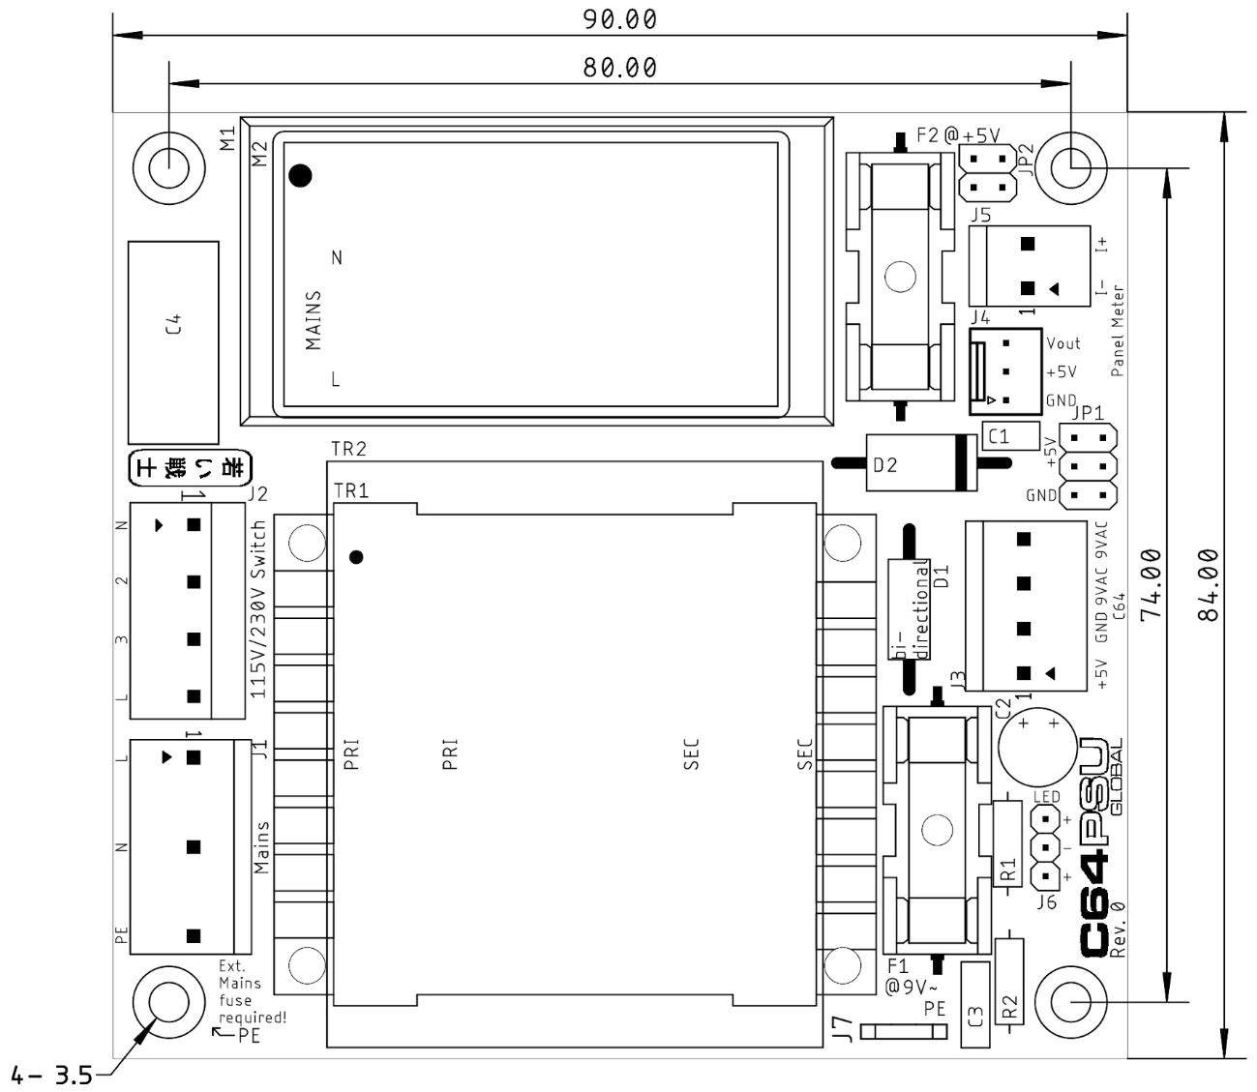

Figure 2: Dimensions

A panel meter can be connected. The common panel meter measures the current in the negative (ground) lead. The panel meters might be very inaccurate and the current and voltage should be adjusted with a load resistor and a multimeter. Sometimes, it is not even possible to adjust the current properly, so the panel meter is not really recommended. In case the panel meter is not installed, JP2 has to be bridged with jumpers.

A not yet developed over voltage protector (aka C64 saver) can be connected to JP1. In case this is not installed, JP1 has to be bridged with jumpers.

An R/C combination (R2/C3) between GND and PE serves for creating System Ground, which is tied to protective earth (PE). Some further power supplies for the monitor or the S-Video/HDMI converters might inject (a weak) mains voltage into the system. This happens due to a capacitive coupling to mains within those PSUs and could be felt when touching the C64 ports.

# Connectors

## J1 – Mains connectors

* Molex KK 396 Header, Vertical, Friction Lock, 5 Circuits, Tin (Sn) Plating (Pin 2 and pin 4 removed): P/N 0026604050
* KK 3.96mm Crimp Terminal Housing, Friction Ramp, 5 Circuits, Natural: P/N 09503051
* KK 396 Crimp Terminal 2478, 18-24 AWG, Bag, Brass Tin (Sn): P/N 08500106.

|  |  |
| --- | --- |
| Pin | Signal |
| 1 | L (hot) |
| 3 | N (neutral) |
| 5 | PE (protective earth) |

## J2 – Mains Voltage Selector

This is an option and only required, if the TR1 (the 115V/230V type) is used.

* Molex 5.08mm Pitch SPOX Wire-to-Board Header, Vertical, with Friction Lock, 4 Circuits, P/N 10321041
* Molex 5.08mm Pitch SPOX Crimp Terminal Housing, 4 Circuits, P/N 10013046
* Molex SPOX Crimp Terminal, 18-24 AWG, Brass, P/N 08701031

As a switch, the type Bulgin T22205B436B is suggested.

## J3 – C64 Power Connector

* Molex KK 396 Header, Vertical, Friction Lock, 4 Circuits, Tin (Sn) Plating:   
  P/N 0026604040
* KK 3.96mm Crimp Terminal Housing, Friction Ramp, 4 Circuits, Natural: P/N 09503041
* KK 396 Crimp Terminal 2478, 18-24 AWG, Bag, Brass Tin (Sn): P/N 08500106.

|  |  |
| --- | --- |
| Pin | Signal |
| 1 | +5V |
| 2 | GND |
| 3 | 9VAC2 |
| 4 | 9VAC1 |

## J4, J5 – Panel Meter

#### J5 – Current path

* Molex KK 396 Header, Vertical, Friction Lock, 2 Circuits, Tin (Sn) Plating:   
  P/N 0026604020
* KK 3.96mm Crimp Terminal Housing, Friction Ramp, 2 Circuits, Natural: P/N 09503021
* KK 396 Crimp Terminal 2478, 18-24 AWG, Bag, Brass Tin (Sn): P/N 08500106.

|  |  |
| --- | --- |
| Pin | Signal |
| 1 | GND PSU (I-) |
| 2 | GND OUT (I+) |

### J4 – Voltage connection

* Molex KK 254 Wire-to-Board Header, Vertical, with Friction Lock, 3 Circuits, Tin (Sn) Plating: P/N 22272031
* KK 254 Crimp Housing, 3 Circuits, Natural: P/N 22-01-3037
* KK 254 Crimp Terminal, 22-30 AWG, Bag, Hot Tin (Sn) Dip Plating: P/N 08500114

|  |  |
| --- | --- |
| Pin | Signal |
| 1 | GND |
| 2 | +5V (supply) |
| 3 | +5V (measurement) |

## Power LED – J6

* Pin header, 1x3 circuits, 2.54mm (0.1”) pitch
* Crimp housing: Dupont crimp housing
* Dupont crimp terminals

It is possible to use a widely available (Ebay, AliExpress etc.) Dupont cable, which can be cut and soldered to the LED.

|  |  |
| --- | --- |
| Pin | Signal |
| 1 | LED + |
| 2 | LED - |
| 3 | LED + |

## J7 – PE Connection

The PE connection to the chassis is accomplished via the mounting hole marked with “← PE”. This is directly connected to the mains connector J1, Pin 5. In case other metal parts have to be grounded, a 6.3 x 0.8 FastOn (spade) connector can be installed in J7.

# Jumpers

## JP1 – Over-Voltage Protection

In case an over-voltage protection is not installed, the pin header JP1 should be bridged. The jumpers should be rated 1A or more.

|  |  |  |  |
| --- | --- | --- | --- |
| Signal | Pin | Pin | Signal |
| Input 5V | 1 | 2 | Output 5V |
| Input 5V | 3 | 4 | Output 5V |
| GND | 5 | 6 | GND |

## JP2 – Current Path of the Panel Meter

The panel meter measures the current between GND and the negative output lead of J3 (power output). In case the panel meter is not connected, JP3 has to be bridged, otherwise the GND will be open and the 5V are not supplied to the C64.

|  |  |  |  |
| --- | --- | --- | --- |
| Signal | Pin | Pin | Signal |
| GND | 1 | 2 | GNDOUT (J3) |
| GND | 3 | 4 | GNDOUT (J3) |

The jumpers should be rated 1A or more.

# Wiring

**This device is connected to mains. Mains voltage is potentially lethal. High currents, that can occur in this device can cause fire hazards. Do not carry out this work, if you are not trained!**

Up to four sorts of crimp contacts are required for installing this device:

* FastOn Flat connectors 6.3 x 0.8 (isolated, red) for mains connector/switch
* Molex SPOX/KK 3.96 (J1, J3, J5)
* Molex SPOX/5.08 (J2, option)
* Molex KK2.54 (option)
* Dupont 2.54mm

The crimp tool for the flat connector (FastOn) are cheap. A tool capable of isolated crimps is required. While crimping is the suggested method, the mains connector/fuse/switch can be soldered (do not forget the shrinkable sleeve) as well.

A crimp tool for the other types of connector is the Engineer PA-20. A cheaper, but less good tool is the IWISS IWS-2820M.

The mains should be wired with 0.75mm²/AWG20 cables.

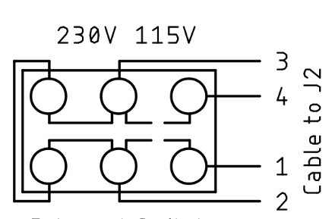

Figure 3: Wiring of the mains voltage selector switch

The Mains Voltage Selector is optional and has to be wired like shown in Figure 3. The wiring should be checked with a multimeter before the PSU Global is powered up.

|  |  |  |
| --- | --- | --- |
| Position | Connected | Open |
| 230V | Pin 2 – 3 | Pin 4 – 3, Pin 1 – 2, Pin 1 – 4 |
| 115V | Pin 3 – 4, Pin 2 – 1 | Pin 2 – 3, Pin 1 – 4 |

Table 1: Mains Voltage Selector checks

The installation of the PSU in a metal enclosure requires connection to PE of all metal parts of this enclosure. These connections need to be proved (at least with a multimeter) after finishing the assembly. One mounting hole of the PCB is connected to the PE of the installation. This is marked “← PE”. Chopper disks are recommended to attain a good connection.

In case, the power cables should stay connected to this PSU, strain reliefs are required. An alternative way is a DIN-jack on the back panel of the power supply and extra cables to have as few cables in the installation as possible.

|  |  |  |
| --- | --- | --- |
| C64 Power Jack | Pin | Voltage |
|  | 1 | - |
| 2 | GND |
| 3 | - |
| 4 | - |
| 5 | +5V |
| 6 | 9VAC(1) |
| 7 | 9VAC(2) |

Table 2: Power jack of the C64

Table 2 shows the power jack of the C64. The view is on the particular contact side. This is identical with the view on the solder side of the respective DIN plugs. The cables soldered to the din plugs should be 0.5mm²/AWG21. It is possible to use 0.75mm²/AWG20 wires, but this might require to clip off some of the wire strands, since the solder cups of the DIN plugs are usually not capable of accepting a wire of this diameter.

After finishing the wiring, it is required to test the complete device. Swapping the voltages by confusing the pins or the wiring will usually damage the connected devices. The +5V should measure between +4.9V and +5.2V. The 9VAC are not regulated and might be quite a bit higher without load. 11VAC is still an acceptable reading.